
Phonics
This week we have continued to learn our phase 2 phonics sounds: t , p .
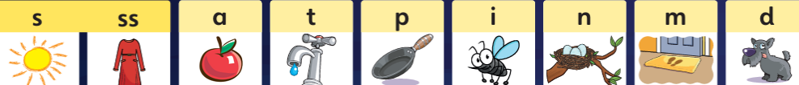
We have been practising sounding out the phonemes and forming the letters correctly.

Home learning:
Your child will have a yellow reading record in their bag.
Inside the front cover you will find a username and password to access Bug Club phonics.
Here the children have access to our Bug Club lessons, videos and games they can play at home.
Please share their wordless reading books with them at home.

Maths
This week, Reception class built on last week's learning about sorting by developing their skills further to compare and sort objects.
The children have been comparing and sorting many things such as coloured bears and different sized objects.
Key vocabulary: big, large, enormous, small, tiny, medium – sized, sort, the same, different, groups, tall, taller, tallest, short, shorter, shortest.
Home learning: Give children an object such as a ruler or a stick. Can they find something longer or shorter than this? Can they find something taller or shorter than this? Can they find something exactly the same length or height as this?
Hello everyone!
The children in Reception class have had another fabulous week with lots of learning and most importantly lots of fun!
The children are following the school routine superbly and building relationships with their peers.

Reception Class Weekly Newsletter
25th September 2026
Awards:
Mathematician of the week:
Aryaan
Our value of the week- Respect:
Aliyah

Well done!


Our Core text next week will be:
We will be reading the traditional tale, Goldilocks and the Three Bears.
We will be focussing on Families.
It would be lovely for the children to share and discuss pictures of their family with their friends.
You can send family pictures to myself over message on the Class Dojo, or bring the photos in.
I would love to create a display/book for the children to look at their family pictures.
Our core text this week was:
The children have really enjoyed exploring this text and have been inspired to share lots of exciting ideas and conversations with their friends.
We loved looking at the many illustrations and discussing with our talking partners: who we would be, where we would go, how we would get there, where we would live and who we’d choose as family and friends.
Home learning: Engage in conversation with your child and encourage them to use the word because to explain and reason their ideas and thoughts.

Thankyou, Miss Smith and the EYFS team.

Important Notes:
- Please label ALL your child’s belongings! (clothes, coats, bags, shoes, etc).

- PE is every Monday (Burnley Community Trust).
Please ensure your child has a PE kit at school: White top, shorts, pumps.

  - Children have access to outdoor learning every day. (We provide waterproofs and wellies. If your child would prefer to keep a set of their own waterproofs and wellies in school, they can do).
-Even though the children do wear waterproofs and wellies, splashing in puddles is lots of fun, so a spare set of socks in their bag would be useful.

- Please can children have water in their water bottles.

- All children are provided with fruit for their healthy snack.

