

Hello, please see what Reception class have been learning this week.
Maths
This week we have been focussing on measuring length and height.
We have been practising how to measure end to end lengths using non-standard units of measurement and rulers.
The children measured different objects, as well as our heights. We used our comparison skills to think about the shortest, longest, smallest and tallest.

Home learning:
Can your child measure different objects at home.
Talk about who is the shortest and tallest in your family.

Watch Numberblocks episode: As tall as the sun.
https://www.bbc.co.uk/iplayer/episode/m001xjcx/numberblocks-series-6-as-tall-as-the-sun
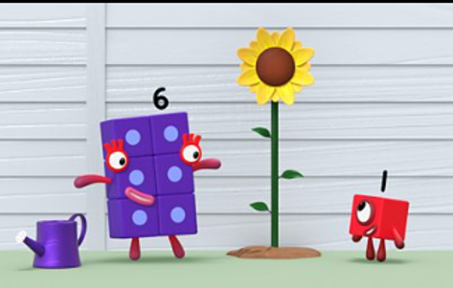

Access Numbots.

Reception Class Weekly Newsletter
12th June 2026.
We have been remembering our phase 2 and phase 3 sounds. We have been using these phonemes applying them to read and spell longer words.

Phonics
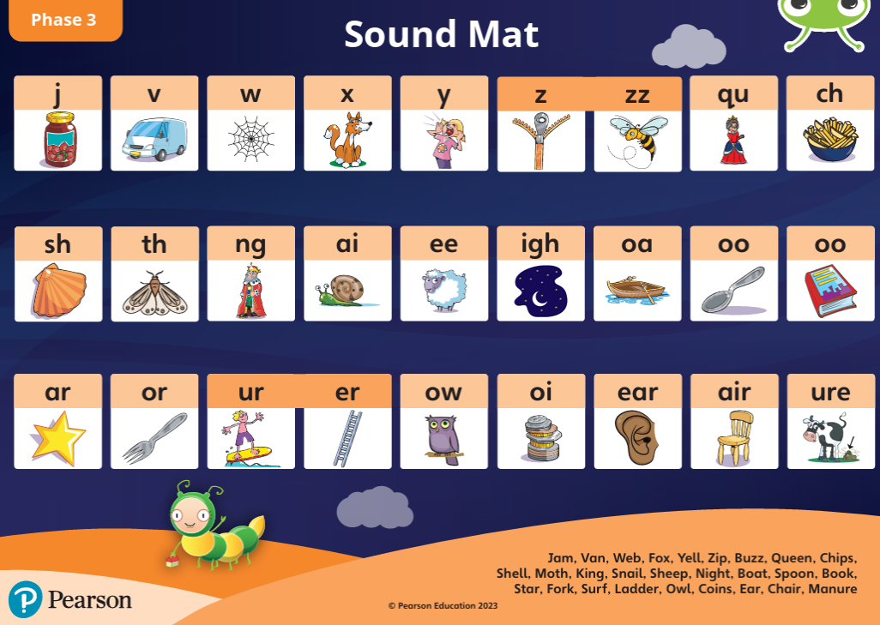

To support your child’s reading:
-Read with your child at least three times a week and sign their reading record.
-Talk about the features of the book: front cover, title, blurb, we read from left to right and notice the page numbers.
-Say the sounds, blend the sounds together to read the words, and recognise the tricky words in the book.
-Spend time looking at the illustrations, commenting/discussing what you can see, what is happening what you think will happen next.
-When reading, children say the sounds and then blend the sounds together to read the word. “S-i-d. ssiid. Sid”.
-Children can speedy read.
-Discuss the comprehension questions together (which are in the back of the book).
To support your child’s writing:
-Say a word from the book (e.g. “Stan”) and ask children to pinch the sounds (S-t-a-n) and they write the word.
-Give the children a sentence from/about the book (e.g. “Stan must run”), they repeat the sentence x3 and write it.
-Ask children to think of their own sentence and write it.
Our core text this week:
Wangari’s Trees of Peace.
This week we have been thinking about Wangari Maathi who is a significant person.
Our text this week is based on a true story and we considered what Wangari did, why she did it and how this inspired other’s.
We also discussed who inspires us?
Awards:
Reader of the week:
Beau

Our value of the week:
Ranayah
Well done!


Next week our core text will be:

Thankyou,
Miss Smith and the Reception team.

Important Notes:
- Please label ALL your child’s belongings! (clothes, coats, bags, shoes, etc).

- PE is every Monday (Burnley Community Trust).
Please bring a PE kit: White top, shorts, pumps.

- Forest school is Wednesday afternoon.

  - Children have access to outdoor learning every day. (We provide waterproofs and wellies. If your child would prefer to keep a set of their own waterproofs and wellies in school, they can do).
-Even though the children do wear waterproofs and wellies, splashing in puddles is lots of fun, a spare set of socks in their bag would be useful.

- Please can children have water in their water bottles.

- All children are provided with fruit for their healthy snack.

