


Hello, please see what Reception class have been learning this week.
Maths
This week we have been focussing on patterns.
We have developed our prior learning on AB patterns (e.g. red, blue, red, blue / circle, triangle, circle triangle).
We are now extending the children’s previous experience of AB patterns to more complex patterns such as AAB, ABC and AABC patterns.
The children have been recognising patterns which develops their skills when making connections and predictions. We have explored patterns in a variety of forms using physical objects and more abstract representations, such as sounds and movement.
Home learning: Can your child create complex patterns at home. Please send photos on Class Dojo, the children love to share these with their friends.
Watch Numberblocks episode: Pattern Palace
https://www.bbc.co.uk/iplayer/episode/b0bp2t8d/numberblocks-series-3-pattern-palace
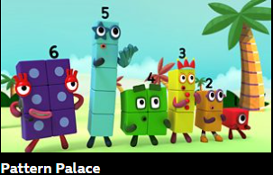

Access Numbots.

Reception Class Weekly Newsletter
5th June 2026.
We have been remembering our phase 2 and phase 3 sounds. We have been using these phonemes applying them to read and spell longer words.

Phonics
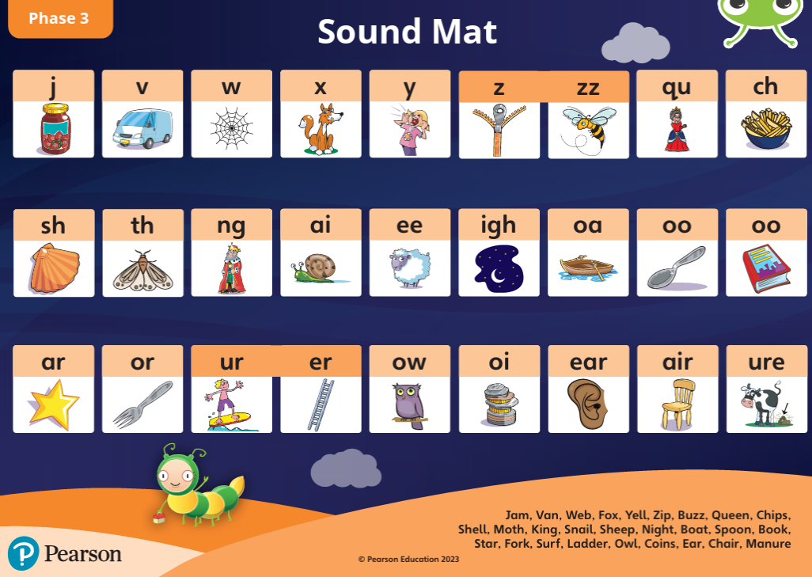

To support your child’s reading:
-Read with your child at least three times a week and sign their reading record.
-Talk about the features of the book: front cover, title, blurb, we read from left to right and notice the page numbers.
-Say the sounds, blend the sounds together to read the words, and recognise the tricky words in the book.
-Spend time looking at the illustrations, commenting/discussing what you can see, what is happening what you think will happen next.
-When reading, children say the sounds and then blend the sounds together to read the word. “S-i-d. ssiid. Sid”.
-Children can speedy read.
-Discuss the comprehension questions together (which are in the back of the book).
To support your child’s writing:
-Say a word from the book (e.g. “Stan”) and ask children to pinch the sounds (S-t-a-n) and they write the word.
-Give the children a sentence from/about the book (e.g. “Stan must run”), they repeat the sentence x3 and write it.
-Ask children to think of their own sentence and write it.
Our core text this week:
We all went on Safari.
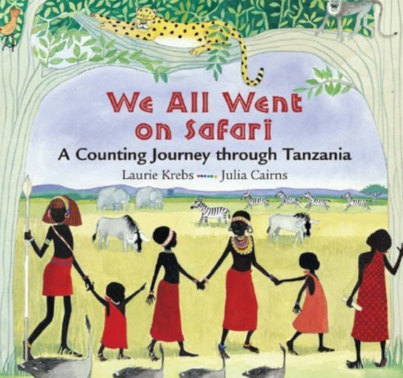
This week we began our new half termly topic “The Wider World”.
We are focussing on Africa and the country Tanzania.
This story is a rhyming and counting story looking at different safari animals.
We have been thinking about the environment discussing the similarities and differences.
Awards:
Mathematician of the week:
Faizan
Our value of the week:
Evie

Well done!


Our core text will be:
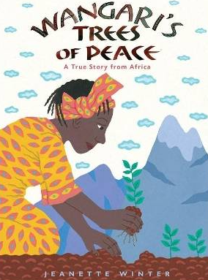

Thankyou,
Miss Smith and the Reception team.

Important Notes:
- Please label ALL your child’s belongings! (clothes, coats, bags, shoes, etc).

- PE is every Monday (Burnley Community Trust).
Please bring a PE kit: White top, shorts, pumps.

- Forest school is Wednesday afternoon.

  - Children have access to outdoor learning every day. (We provide waterproofs and wellies. If your child would prefer to keep a set of their own waterproofs and wellies in school, they can do).
-Even though the children do wear waterproofs and wellies, splashing in puddles is lots of fun, a spare set of socks in their bag would be useful.

- Please can children have water in their water bottles.

- All children are provided with fruit for their healthy snack.

