
Hello, please see what Reception class have been learning this week.
Maths

In math's this week we have been thinking about counting beyond 20.
The children have been recognising and remembering the counting pattern.
We have been doing lots of verbal counting using objects, pictures and number lines.

Home Learning:
Watch Numberblocks episode: Step squad.
https://www.bbc.co.uk/iplayer/episode/m00029vq/numberblocks-series-3-step-squads?seriesId=b08bzfnh-structural-3-b0bls7vy

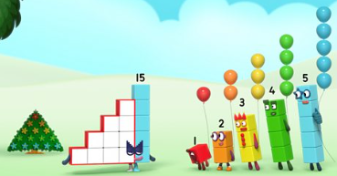

Access Numbots.

Reception Class Weekly Newsletter
22nd May 2026.
We have learnt all our phase 2 and phase 3 sounds, so we will begin phase 4 phonics after half term.
Phase 4 does not introduce any new phonemes (sounds), but we consolidate previously learned phonemes and apply them to read and spell longer words.

Phonics

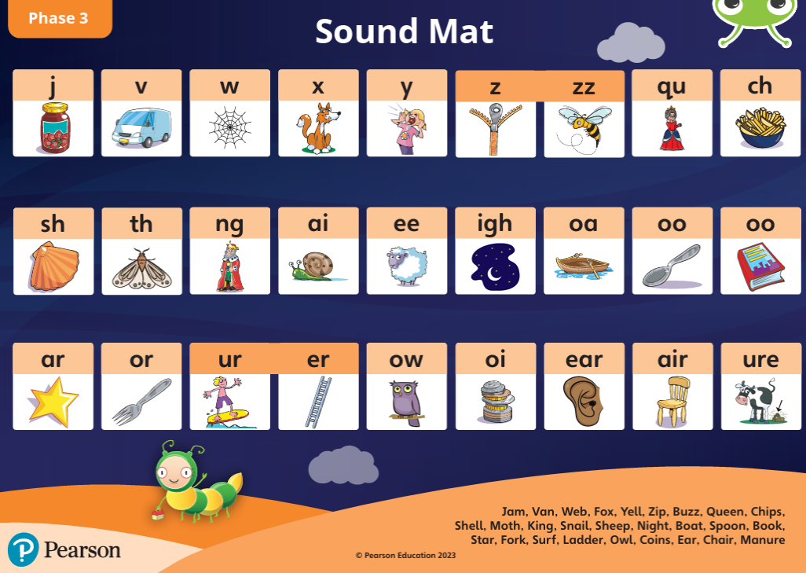
Reading at home-
-Read at home with your child, sign their reading records and your child will receive Dojo points!!!
-Talk about the features of the book: front cover, title, blurb, we read from left to right and noticing the page numbers.
-Spend time looking at the illustrations, commenting/discussing what you can see, what you think will happen next.
-Encourage children recognising, saying the sounds and then blending the sounds together to read the word.
-Discuss the comprehension questions together (which are in the back of the book). This supports children’s understanding.
Bug Club phonics-online learning-
Your child will have a yellow reading record in their bag.
Inside the front cover you will find a username and password to access Bug Club phonics.
Here the children have access to our Bug Club lessons, videos and games they can play at home.

Next half term our topic is:
The Wider World.
Our core text will be:

Awards:
Writer of the week:
Minah

Our value of the week:
Zayaan

Well done!


Our core text this week:
The Queen’s Hat.
This week we have continued our learning of London.
The children have:
-Used Bee-Bots to develop our mapping skills.
-Created a story map using their own ideas.
-Learnt the rhymes ‘The Grand Old Duke of York’ and ‘London Bridge is Falling Down’

Thankyou,
Miss Smith and the Reception team.

Important Notes:
- Please label ALL your child’s belongings! (clothes, coats, bags, shoes, etc).

- PE is every Monday (Burnley Community Trust).
Please bring a PE kit: White top, shorts, pumps.

- Forest school is Wednesday afternoon.

  - Children have access to outdoor learning every day. (We provide waterproofs and wellies. If your child would prefer to keep a set of their own waterproofs and wellies in school, they can do).
-Even though the children do wear waterproofs and wellies, splashing in puddles is lots of fun, a spare set of socks in their bag would be useful.

- Please can children have water in their water bottles.

- All children are provided with fruit for their healthy snack.

