
Hello, please see what Reception class have been learning this week.
Maths
In math's this week we have been thinking about odd and even numbers.
The children know that even numbers CAN be made of 2 parts that are the same.
We used our prior knowledge of doubling where we explored two equal groups and reinforced our stem sentence.
_____ is made of _____ and ____; _____ and _____ make _____.
For example: “4 is made of 2 and 2; 2 and 2 make 4”.
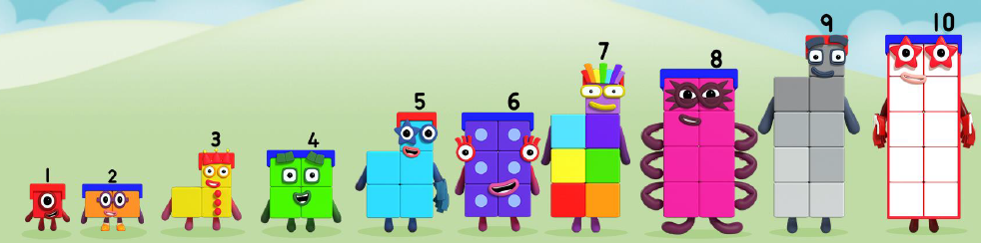
Home Learning:
Watch Numberblocks episode: Odds and evens.
https://www.bbc.co.uk/iplayer/episode/b08r2l4d/numberblocks-series-2-odds-and-evens
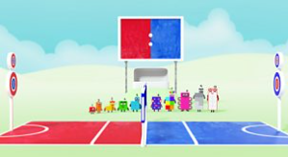
Access Numbots.

Reception Class Weekly Newsletter
15th May 2026.
We have learnt all our phase 2 and phase 3 sounds, so we will begin phase 4 phonics after half term.
Phase 4 does not introduce any new phonemes (sounds), but we consolidate previously learned phonemes and apply them to read and spell longer words.

Phonics

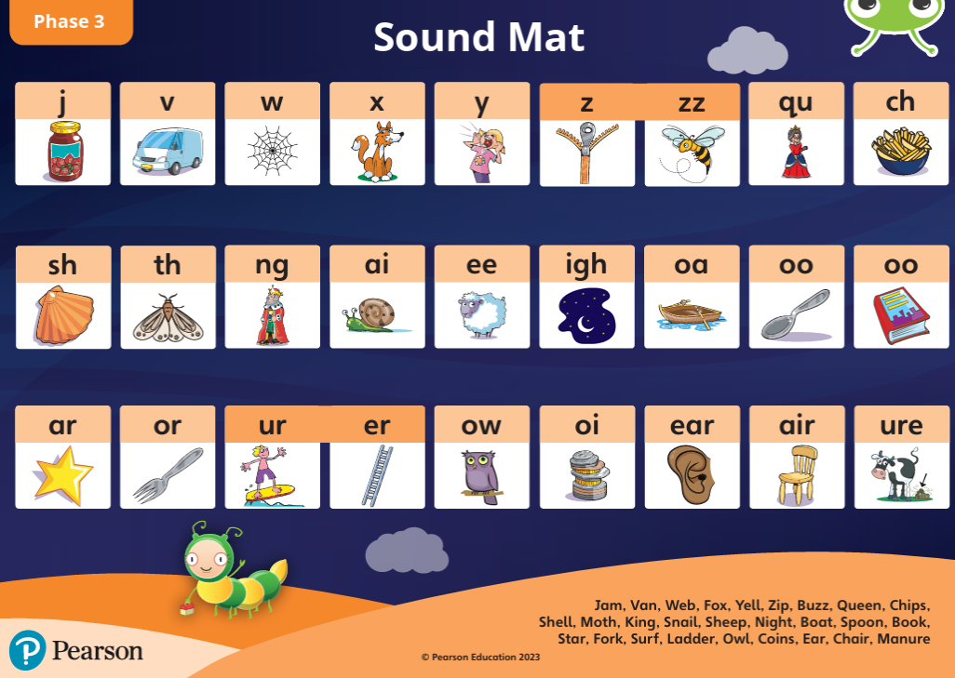
Reading at home-
-Read at home with your child, sign their reading records and your child will receive Dojo points!!!
-Talk about the features of the book: front cover, title, blurb, we read from left to right and noticing the page numbers.
-Spend time looking at the illustrations, commenting/discussing what you can see, what you think will happen next.
-Encourage children recognising, saying the sounds and then blending the sounds together to read the word.
-Discuss the comprehension questions together (which are in the back of the book). This supports children’s understanding.
Bug Club phonics-online learning-
Your child will have a yellow reading record in their bag.
Inside the front cover you will find a username and password to access Bug Club phonics.
Here the children have access to our Bug Club lessons, videos and games they can play at home.

Our core text will be:

Awards:
Reader of the week:
Abdul

Our value of the week:
Emaan

Well done!


Our core text this week:
The Queen’s Hat.
This week we have continued our half term topic “Exploring England” by exploring England’s capital city, London.
We have been developing our knowledge of our country, as we looked at the London Landmarks and the Royal Family.
The children had lots of questions to ask about London.

Thankyou,
Miss Smith and the Reception team.

Important Notes:
- Please label ALL your child’s belongings! (clothes, coats, bags, shoes, etc).

- PE is every Monday (Burnley Community Trust).
Please bring a PE kit: White top, shorts, pumps.

- Forest school is Wednesday afternoon.

  - Children have access to outdoor learning every day. (We provide waterproofs and wellies. If your child would prefer to keep a set of their own waterproofs and wellies in school, they can do).
-Even though the children do wear waterproofs and wellies, splashing in puddles is lots of fun, a spare set of socks in their bag would be useful.

- Please can children have water in their water bottles.

- All children are provided with fruit for their healthy snack.

