
Hello, please see what Reception class have been learning this week.
Maths
The children have been consolidating their knowledge on the composition of numbers to 10. They have been representing number on ten frames this week. The ten frames support children to visually recognise number. We have been matching different variations of number.
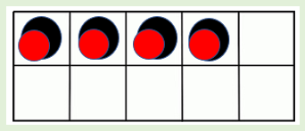
“A ten frame has ten spaces, 2 rows of 5”.
“There are 4 full, 6 empty and 10 altogether. 4 and 6 is 10”.

Home Learning:
Watch Numberblocks episode: Ten again.
https://www.bbc.co.uk/iplayer/episode/b0bn5k6h/numberblocks-series-3-ten-again?seriesId=b08bzfnh-structural-3-b0bls7vy

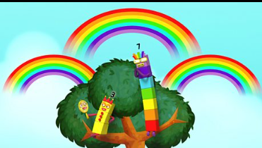

Access Numbots.

Reception Class Weekly Newsletter
24th April 2026.
Phonics
This week we have revisited our phase 2 phonemes (sounds) and continued to learn our phase 3 phonemes: ear.

The phoneme ‘ear’ is a trigraph (three letters that make one sound).
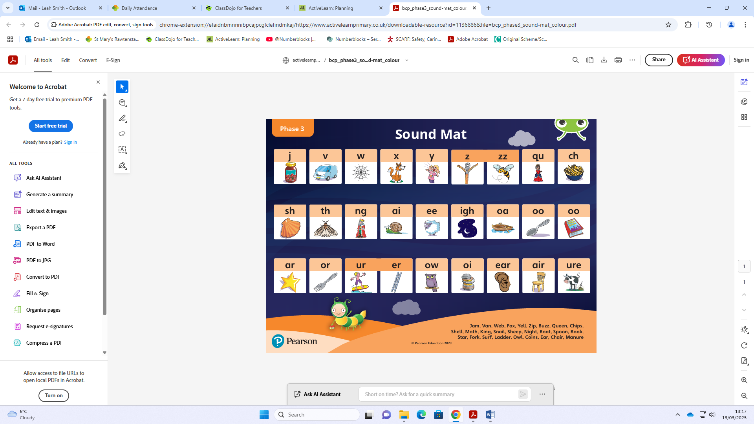
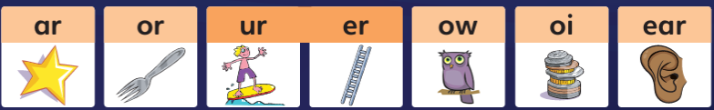
Home learning:
Reading at home-
-Read at home with your child, sign their reading records and your child will receive Dojo points!!!
-Talk about the features of the book: front cover, title, blurb, we read from left to right and noticing the page numbers.
-Spend time looking at the illustrations, commenting/discussing what you can see, what you think will happen next.
-Encourage children recognising, saying the sounds and then blending the sounds together to read the word.
-Discuss the comprehension questions together (which are in the back of the book). This supports children’s understanding.
Bug Club phonics-online learning-
Your child will have a yellow reading record in their bag.
Inside the front cover you will find a username and password to access Bug Club phonics.
Here the children have access to our Bug Club lessons, videos and games they can play at home.

Awards:
Reader of the week:
Jacob
Our value of the week:
Ayaan
Well done!


Our core text this week:
The Tiny Seed
We continued to think about seasonal changes this week as we explored another text by our class author, Eric Carle.
We explored what plants need to grow, how they grow and how to plant a seed. We have been planting sunflower seeds and are excited to help and see them grow!
In forest school we have been doing observational drawings of plants and labelling the different parts of the plant.

Summer 1:
Our core text next week:

Important Notes:
- Please label ALL your child’s belongings! (clothes, coats, bags, shoes, etc).

- PE is every Monday (Burnley Community Trust).
Please bring a PE kit: White top, shorts, pumps.

- Forest school is Wednesday afternoon.

  - Children have access to outdoor learning every day.
Please send your child to school with a sun hat & sun cream on the hot, sunny, days.

- Please can children have water in their water bottles.

- All children are provided with fruit for their healthy snack.
Thankyou,
Miss Smith and the Reception team.

