 | Week 1 | Week 2 | Week 3 | Week 4 | Week 5 | Week 6
Key Theme covered | Exploring England
Core Text | What Can You See in Spring?  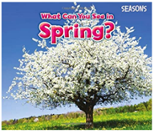 | The Tiny Seed  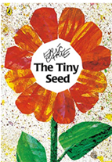 | The Very Hungry Caterpillar  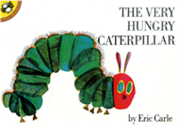 | 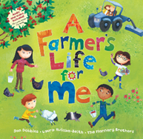 | The Queen’s Hat | 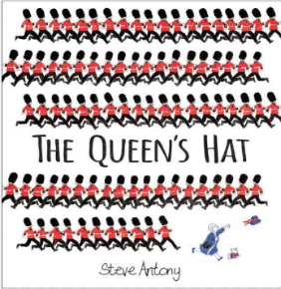  The Queen’s Hat
Key Topic Skills Covered | We will be developing our prior knowledge of seasons describing the signs of spring. We will talk about the changes we notice and changes over time.  We will carry out research, to find out about seasons and plants.  The children will be able to explain what they know and what they have learnt about the natural world. | We will show an interest in and be curious about the natural world.  The children will develop their skills to “compare/sort/group/  identify/classify:”  as they notice similarities, notice differences  in the natural world, including plants.  We will record our findings through observational drawings of plants.  We will use simple vocabulary to name and describe objects, materials, living things and environments. | We will explore this story wrote by our class author, with a focus on minibeasts.  We will notice similarities and differences between different minibeasts.  When exploring exploring minibeasts, we will use equipment to make observations, (e.g. magnifiers, digital microscopes, etc).  we notice and changes over time. | Our focus is on farmyard animals, with our class trip to Smithill’s Farm.  We will notice similarities, notice differences in the natural world, including animals.  We will explore and observe first-hand, looking closely at/noticing features in the natural world including animals. | The focus is London.  We will be developing our knowledge of our country, as we talk about the features of the immediate environment and other places (London).  The children will comment and ask questions about their immediate environment, other places which are familiar to them, and places they have learnt about (London). | The children will use technology and IT equipment to make observations or find information about different locations and places.  We will further our mapping skills as we recognise, know about and describe features of different places they have learnt about through non - fiction texts, stories, maps, visits, visitors, etc.
Key Language | Contents, glossary, hatch, daffodil, bloom. | Seed, root, petals, stem, tall. | egg, caterpillar, butterfly, cocoon, delicate. | farmer, milking, piglets, meadow, bleat. | London, Queen, city, floated | Park, town, supermarket, library, bus station, high street.

Key Songs  and Rhymes | - There’s a tiny caterpillar on a leaf, wiggle wiggle.  - There’s a worm at the bottom of the garden.  - Old McDonald had a farm.  - Chick, Chick, Chick, Chick, Chicken, Lay a little egg for me.  - Spring Song: “It is spring time, It is spring time, Winter's gone, Winter's gone, Summer time will come soon, Summer time will come soon, It won't be long, It won't be long”.  - I’ll Plant a little seed: “I'll plant a little seed in the dark, dark ground. Out comes the yellow sun, big and round. Down comes the cool rain, soft and slow. Up comes the little seed, grow, grow, grow!”.  - The grand old Duke of York.

