
Maths
In maths this week the children have been using many of their mathematical skills, including subitising and composition of number as we focused on comparison.
This week the children were encouraged to focus exclusively on the numerosity of sets, without being diverted by colour, shape or size. We noticed when quantities were equal or unequal, and began to manipulate the number of objects in 2 sets to make them equal.
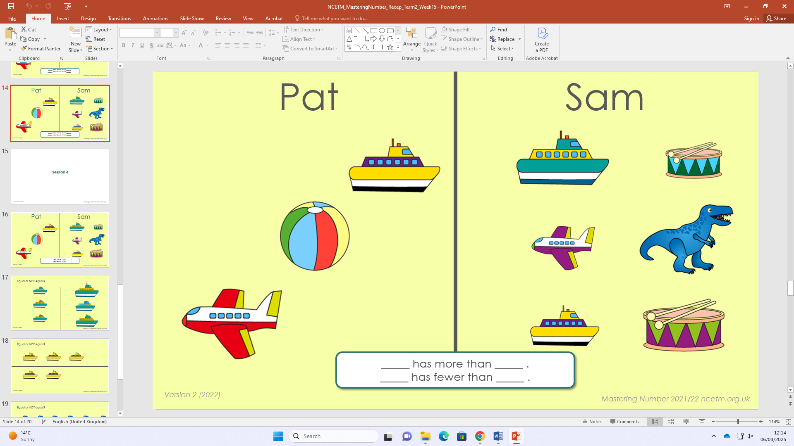
Home Learning:
Watch Numberblocks episode: ‘Building Blocks’.
https://www.bbc.co.uk/iplayer/episode/b0bmkj57/numberblocks-series-3-building-blocks?seriesId=b08bzfnh-structural-3-b0bls7vy

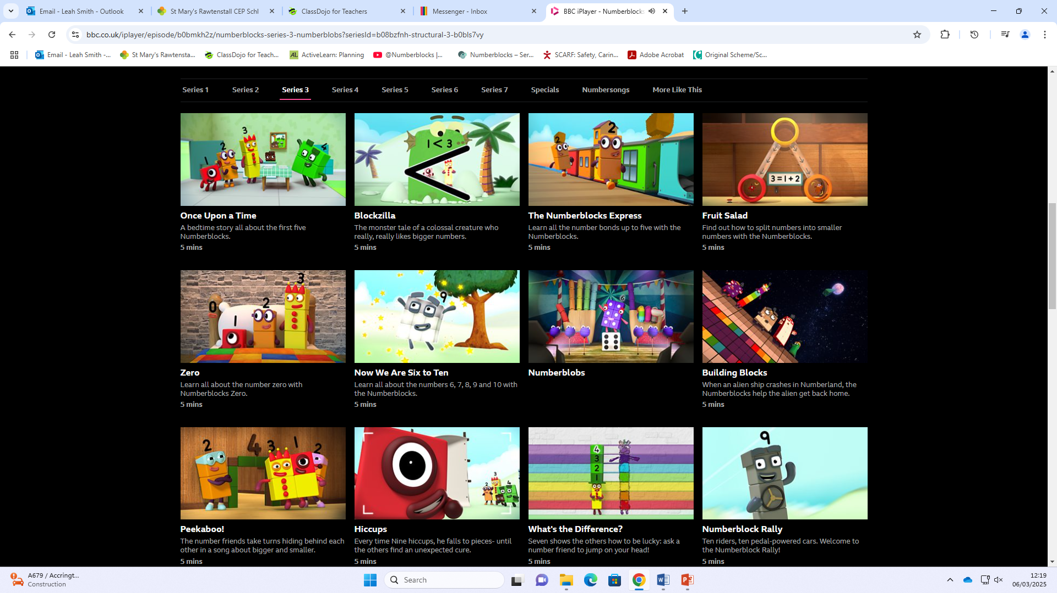

Hello, please see what Reception class have been learning this week.

Reception Class Weekly Newsletter
6th March 2026.
Phonics
This week we have revisited our phase 2 phonemes (sounds) and continued to learn our phase 3 phonemes: oa.

The phoneme ‘oa’ is a digraph (two letters that make one sound).

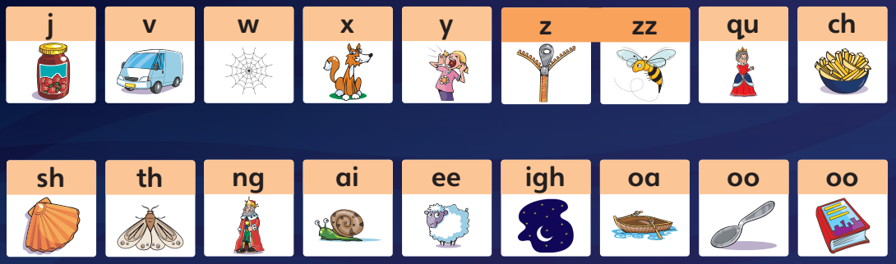
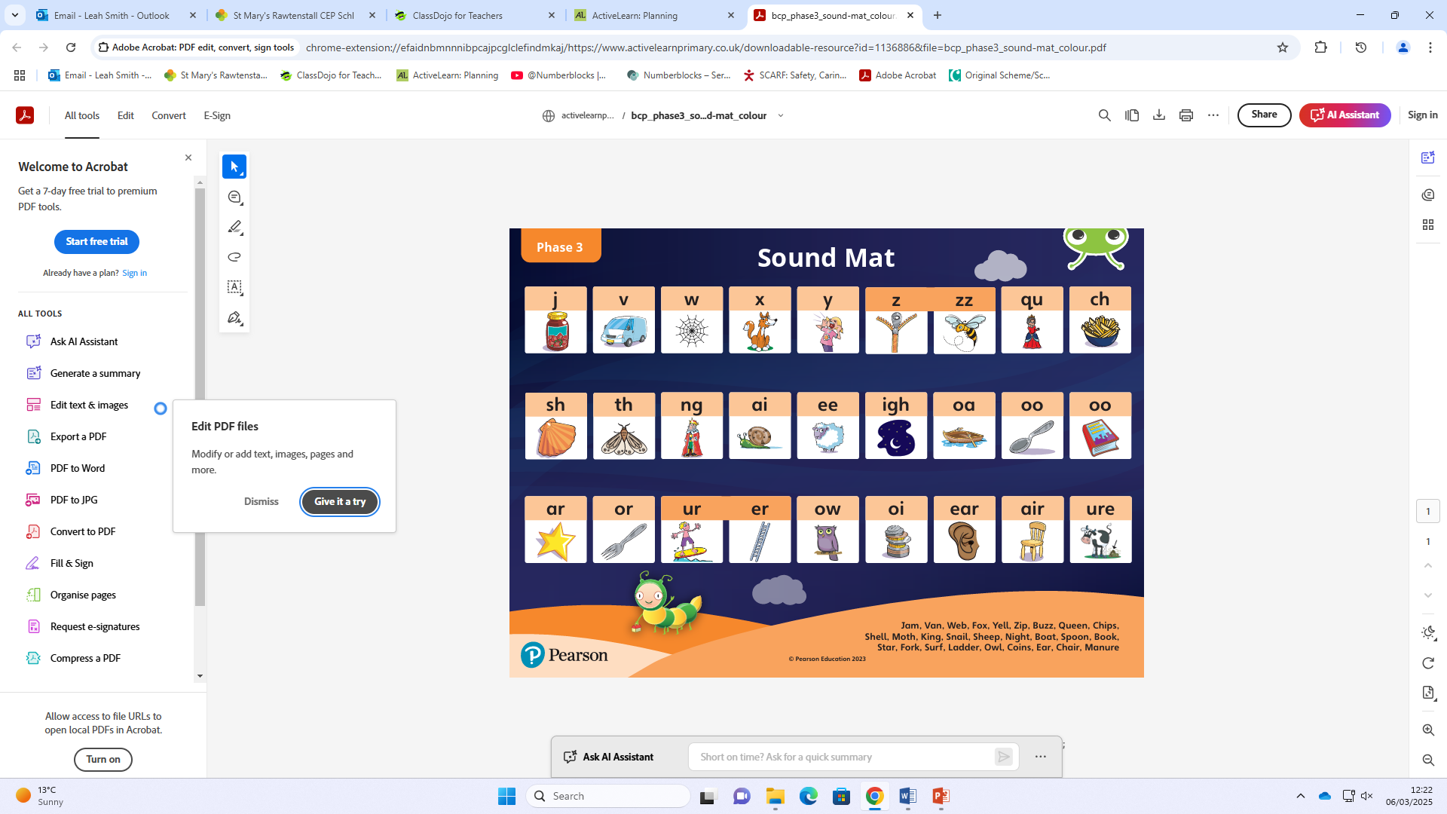
Home learning:
Reading at home-
-Read at home with your child, sign their reading records and your child will receive Dojo points!!!
-Talk about the features of the book: front cover, title, blurb, we read from left to right and noticing the page numbers.
-Spend time looking at the illustrations, commenting/discussing what you can see, what you think will happen next.
-Encourage children recognising, saying the sounds and then blending the sounds together to read the word.
Bug Club phonics-online learning-
Your child will have a yellow reading record in their bag.
Inside the front cover you will find a username and password to access Bug Club phonics.
Here the children have access to our Bug Club lessons, videos and games they can play at home.
Oral blending-
Children must be able to oral blend before blending to read words.
Play: “What’s my word?” and use your ‘robot voice’.

Our core text this week:
Peepo!.
We have continued our topic ‘Roaming around Rawtenstall’,
considering the past.
The children have enjoyed listening to a new story as we discussed the roles people had in the past and we explored toys from the past including: a rocking horse, a rag doll and marbles.
The children particularly loved learning how to play different games with marbles.

Awards:
Writer of the week:
Beckett
Our value of the week- Friendship:
Faizan

Well done!


Our core text next week:

The Naughty Bus.

Thankyou,
Miss Smith and the Reception team.

Important Notes:
- Please label ALL your child’s belongings! (clothes, coats, bags, shoes, etc).

- PE is every Monday (Burnley Community Trust).
Please bring a PE kit: White top, shorts, pumps.

- Forest school is Wednesday afternoon.

  - Children have access to outdoor learning every day. (We provide waterproofs and wellies. If your child would prefer to keep a set of their own waterproofs and wellies in school, they can do).
-Even though the children do wear waterproofs and wellies, splashing in puddles is lots of fun, a spare set of socks in their bag would be useful.

- Please can children have water in their water bottles.

- All children are provided with fruit for their healthy snack.

