
Maths
In maths this week the children have been continuing to focus on composition.
We have recalled our prior learning and knowledge of how to make numbers to 5 (e.g. 1 and 4 makes 5, 3 and 2 makes 5).
The children have been using the Hungarian number pattern to explore composing numbers 6 and 7. (e.g. 5 and 1 is 6 , 5 and 2 is 7).
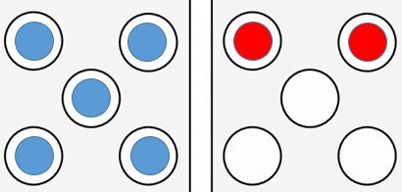
Home Learning:
Watch Numberblocks episode: ‘Numberblobs’.
https://www.bbc.co.uk/iplayer/episode/b0bmkh2z/numberblocks-series-3-numberblobs?seriesId=b08bzfnh-structural-3-b0bls7vy

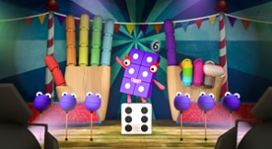
Hello everyone, please see what Reception class have been learning this week.

Reception Class Weekly Newsletter
27th February 2026.
Phonics
This week we have revisited our phase 2 phonemes (sounds) and continued to learn our phase 3 phonemes: ee and igh.

The phoneme ‘ee’ is a digraph (two letters that make one sound).
The phoneme ‘igh’ is a trigraph (three letters that make one sound).

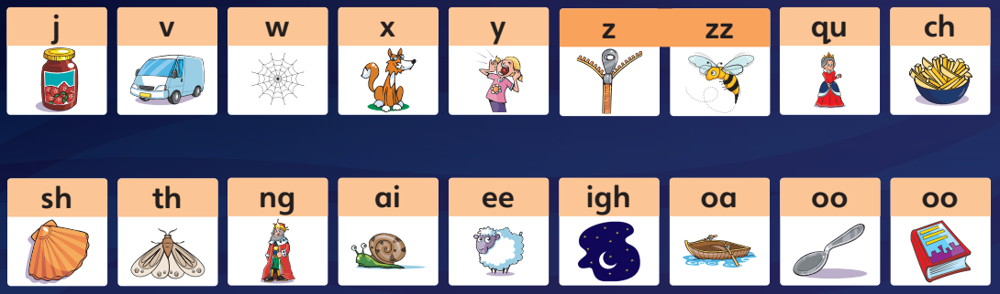
Home learning:
Reading at home-
-Read at home with your child, sign their reading records and your child will receive Dojo points!!!
-Talk about the features of the book: front cover, title, blurb, we read from left to right and noticing the page numbers.
-Spend time looking at the illustrations, commenting/discussing what you can see, what you think will happen next.
-Encourage children recognising, saying the sounds and then blending the sounds together to read the word.
Bug Club phonics-online learning-
Your child will have a yellow reading record in their bag.
Inside the front cover you will find a username and password to access Bug Club phonics.
Here the children have access to our Bug Club lessons, videos and games they can play at home.
Oral blending-
Children must be able to oral blend before blending to read words.
Play: “What’s my word?” and use your ‘robot voice’.

Awards:
Reader of the week:
Emaan

Our value of the week- Friendship:
Zayaan

Well done!


Our core text next week:

Peepo!

Our core text this week:
In Every House, On Every Street.
We have started our new topic ‘Roaming around Rawtenstall’,
thinking about the present.
The children have enjoyed listening to a new story as we discussed our homes, the roles people have in our homes and the favourite room in our home and why.

Thankyou,
Miss Smith and the Reception team.

Important Notes:
- Please label ALL your child’s belongings! (clothes, coats, bags, shoes, etc).

- PE is every Monday (Burnley Community Trust).
Please bring a PE kit: White top, shorts, pumps.

- Forest school is Wednesday afternoon.

  - Children have access to outdoor learning every day. (We provide waterproofs and wellies. If your child would prefer to keep a set of their own waterproofs and wellies in school, they can do).
-Even though the children do wear waterproofs and wellies, splashing in puddles is lots of fun, a spare set of socks in their bag would be useful.

- Please can children have water in their water bottles.

- All children are provided with fruit for their healthy snack.

