
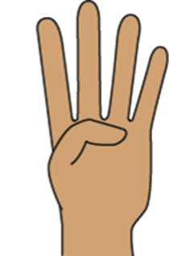
Maths

The maths focus this week: counting, ordinality and cardinality.
- To find out ‘how many’ objects there are.
- 1-1 correspondence when counting and representing amounts.
- Develop their understanding of the concept of cardinality (the last number in the count tells us ‘how many’ things there are altogether).
- The children have been exploring verbal counting to larger numbers. Singing counting rhymes will give them opportunities to hear, join in with and develop their knowledge of the counting sequence.

Home Learning:

•Make biscuits or cupcakes, and ask the children to decorate them with target numbers of raisins or similar toppings.

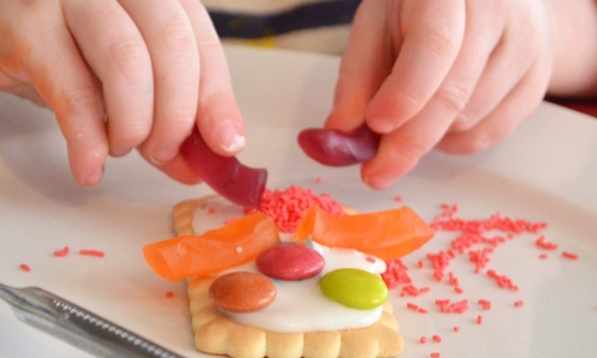

Reception Class Weekly Newsletter
23rd January, 2026.
Phonics
This week we have continued to revisit our phase 2 sounds and we have learnt the phase 3 phonemes: y and z.

The children have practised saying and recognising the phoneme, blending words with our new phonemes and practising writing the graphemes (letters) using the correct formation.

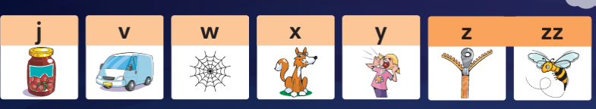
Home learning:
-Your child will have a reading book.
(Please read with your child daily and sign their reading record).
Talk about the features of the book: front cover, title, blurb, we read from left to right and noticing the page numbers.
Spend time looking at the illustrations, commenting/discussing what you can see, what you think will happen next.
-Emphasise the initial sounds, e.g. “ssss sand” ,“b bag”.
-In phonics we decode. Use your robot voice h-a-t. “I can see a h-a-t, hat”. (This will support your child to blend sounds together as they learn to read).
-Play I spy. “I spy something beginning with the sound “t”.

-When reading, children say the sounds and then blend the sounds together to read the word.
“S-i-d. ssiid. Sid”.

Awards:
Mathematician of the week:
Sanjot

Our value of the week- Love:
Beau

Well done!


Our core text next week:

Our core text this week was:
We focussed on a poem this week:
A Rainy Day
by Rhiannon Oliver.

We have been thinking about what is a poem?
The children listened for the rhyming words, created actions and performed the poem.
Throughout the week we have been exploring waterproof and non-waterproof materials, floating and sinking.
We also put on our wellies, waterproofs and had lots of fun playing in the rain, jumping in puddles and catching the rain on our tongues!
Thankyou,
Miss Smith and the Reception team.

Important Notes:
- Please label ALL your child’s belongings! (clothes, coats, bags, shoes, etc).

- PE is every Monday (Burnley Community Trust).
Please bring a PE kit: White top, shorts, pumps.

- Forest school is Wednesday afternoon.

  - Children have access to outdoor learning every day. (We provide waterproofs and wellies. If your child would prefer to keep a set of their own waterproofs and wellies in school, they can do).
-Even though the children do wear waterproofs and wellies, splashing in puddles is lots of fun, a spare set of socks in their bag would be useful.

- Please can children have water in their water bottles.

- All children are provided with fruit for their healthy snack.

