 | Week 1 | Week 2 | Week 3 | Week 4 | Week 5 | Week 6 | Week 7&8
Key Theme covered | Festivals and Celebrations
Core Text | 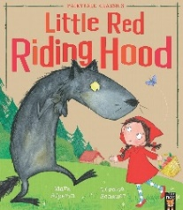  Little Red Riding Hood | The Best Diwali Ever  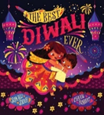 | All Kinds of Beliefs  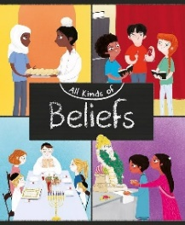 | The Twirly Wiggly Dance  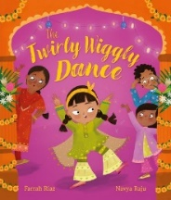 | 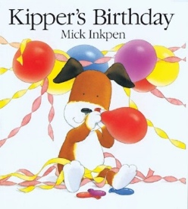  Kippers Birthday | Light the Lights  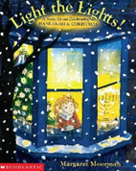 | 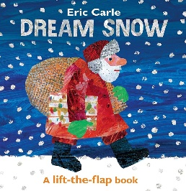  Dream Snow – Eric Carle
Key Topic Skills Covered | We will be showing an interest in significant events and experiences. Talking about and describing features of our own lives, and describing features of the lives of people in the community.  Key Vocabulary: Fabulous, red, favourite, cloak, surprise, bright, skipped, peeping, growled, gather, squeaked, whispered, slammed, big ears, big hairy arms, big teeth, snarled, pounced, terrified. | We will comment on significant events in own lives and talk about the local community. Know about how people are similar, how people are different in language, religion and culture.  Look closely at and observe the lives of people in communities in other countries within the world.  Key Vocabulary:  Diwali, festival, celebration, divas, special clothes, cousins, fireworks, rangoli, temple, prayers, patterns, sparkler. | We will look closely and consider our own culture and religion and that of the people in the community.  We will describe culture and religion in relation to ourselves, friends, family, and other people within the community based on our experiences, events and objects.  Key Vocabulary:  All kinds of beliefs, Buddhists, Christians, Hindus, Jews, Muslims, Sikhs, non-religious beliefs. We can show what we believe by how we dress, what we eat, how we behave, and how we treat other people. What are your beliefs? | We will comment on significant events in own lives, talking about our family.  Know about how people are similar, how people are different in gender and ethnicity. Use language skills to share experiences.  We will respect other people including their ideas, feelings, beliefs.  Key Vocabulary:  Wedding, complicated, invitation, popular, Walima, practise, invented, Mehndi, Henna, | The focus will be on talking about key events, in own lives, about family and friends.  We will make comparisons and  talk to others about what we know about an event from the past.  Key Vocabulary:  Birthday, busy, stirred, mixture, squeezed, bake, decoration, deliver, carefully, waited, hungry, stretched, sleepy, crashed, streamed, snored peacefully, puzzled, presents, disappointed, useful. | We will be recognising the similarities and differences in culture and religion between them and other communities.  Key Vocabulary:  Winter, cold, dark, morning, father, Hanukkah, gleamed, steadied, candle, ceremony, beautiful, reflected, ornaments, search, fragile, tinsel, Christmas eve, dawn, dark winter nights. | We will be looking closely and considering our own culture and religion and that of the people in their own community.  Key Vocabulary:  Farm, farmer, few, barn, evening, cosy, tired, dreamed, snowflakes, gently, white blanket, snow, sparkled, safe, warm, grabbed, sack, dashed, shouted, wondered, Merry Christmas.

Key Songs  and Rhymes | The Natural World  - Rain Rain go away, come again another day.  - It’s raining it’s pouring.  - I hear thunder.  - Firework number rhyme  “5 pretty fireworks, Zooming way up high, 1 went BANG! And lit up the sky!  4 pretty fireworks, Zooming way up high, 1 went BANG! And lit up the sky!  3 pretty fireworks, Zooming way up high, 1 went BANG! And lit up the sky!  2 pretty fireworks, Zooming way up high, 1 went BANG! And lit up the sky!  1 pretty firework, Zooming way up high, 1 went BANG! And lit up the sky”  People, Cultures and Communities  - To celebrate Diwali  This is the way we light the lamps, Light the lamps, Light the lamps. This is the way we light the lamps, To celebrate Diwali!  This is the way we eat our sweets, Eat our sweets, Eat our sweets. This is the way we eat our sweets, To celebrate Diwali!  This is the way we give out gifts, Give out gifts, Give out gifts. This is the way we give out gifts, To celebrate Diwali!  This is the way we clean our homes, Clean our homes, Clean our homes. This is the way we clean our homes, To celebrate Diwali!  - Happy birthday (pretend with teddies).  Christmas  - When Santa Got Stuck Up the Chimney  - Father Christmas  Father Christmas, Father Christmas, He got stuck, he got stuck, Coming down the chimney, Coming down the chimney What bad luck, WHAT BAD LUCK!  - Jingle Bells  - Here We Go Round the Christmas Tree  Here we go round the Christmas tree, The Christmas tree, the Christmas tree, Here we go round the Christmas tree, on a cold and frosty morning.  This is the way we open our presents, open our presents, open our presents. This is the way we open our presents, on a cold and frosty morning.  This is the way we eat our mince pies...  This is the way we pull on a cracker.

